Basic integrate and fire model;



Entire membrane conductance is modelled as a single passive leakage (above)

K+ rate functions (delayed rectifier)

The rate at which the open probability changes:

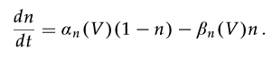

Divide by



* 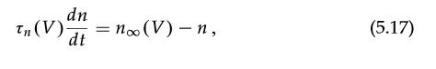

Indicates that for fixed Voltage V, n approaches the limiting Value  exponentially with the time constant (tau_n)

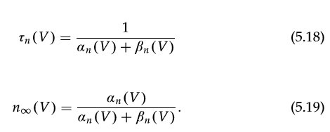

An(V) and Bn(V) based on thermodynamics, leads to this:



From equation 5.19 we can substitute and find the Nequil is sigmoidal in behaviour

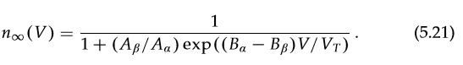

Depolarization causes n to grow to 1, and hyperpolarization causes n to shrink to 0.

These thermodynamic assumptions often don’t fit perfectly, therefore the data used to fit these models is based on patch clamping.